Arizona Historical Society
Southern Arizona Chapter Board Meeting
& SOUTHERN ARIZONA ANNUAL MEMBERSHIP MEETING
October 3, 2018

Present: Elaine Becherer, Bill Cavaliere, Yvonne Clay, Betty Cook, Jeff Horwitz, Walter Lane, Craig McEwan, Mark O’Hare, Shirley Pinkerton, Frank Ratey (Los Amigos representative), Jim Sell, Susanne Walsh and Ralph Wong

Absent: John Flynn (Pathfinder representative), Ron Green, Linda Head, and Bob Vint

Staff Present: Les Roe (Vice President Exhibitions), and Kate Stewart (Archivist & Librarian)

Guests Present: Dr. James Burns, Director of the Arizona Historical Society

Call to Order

President Walter Lane called the meeting to order at 3:06 p.m.

Roll Call
Board members introduced themselves and a quorum was declared.

Approval of Board Minutes

The minutes of the 2017 Annual Membership Meeting were unanimously approved after a motion from Bill Cavaliere and seconded by Frank Ratey.
The minutes, as corrected, of the July 9, 2018 Chapter Board meeting was unanimously approved after a motion from Jeff Horwitz and seconded by Craig McEwan.

USAM 21161 Fund Report

Treasurer Shirley Pinkerton stated that we have $22,693.00 in the account.

President’s Report

President Walter Lane stated that he had sent a memo to President Voie Coy regarding the future of the Chapter Board. He further stated that President Coy had replied that if we were to dissolve the Chapter Board, we would have to get Legislative authority to do that because of State Statute. He suggested that we could change the meeting schedule from four times per year to once a year, but at present our Chapter Bylaws state that we will meet four times per year. We could look at changing the Bylaws. Both Les Roe and Dr. Burns supported the Chapter making whatever changes make sense.

Director’s Report

Les Roe made the Director’s Report. He stated that there was good progress on the Resilience Gallery. The Otero Porch roof restoration has now begun with a fabulous contractor and by the time of our next meeting, the restoration should be complete. The Resilience Exhibit should have its opening in January.

New Business

The first item under new business was a presentation by our new Director, Dr. James Burns on the reorganization of the Arizona Historical Society. His presentation included a PowerPoint highlighting the changes. He stated due to the reduction of staff and financial resources over the last many years and to capitalize on the talents and skills of the current staff, this reorganization was necessary. He announced the new mission, vision and guidelines of AHS as follows:

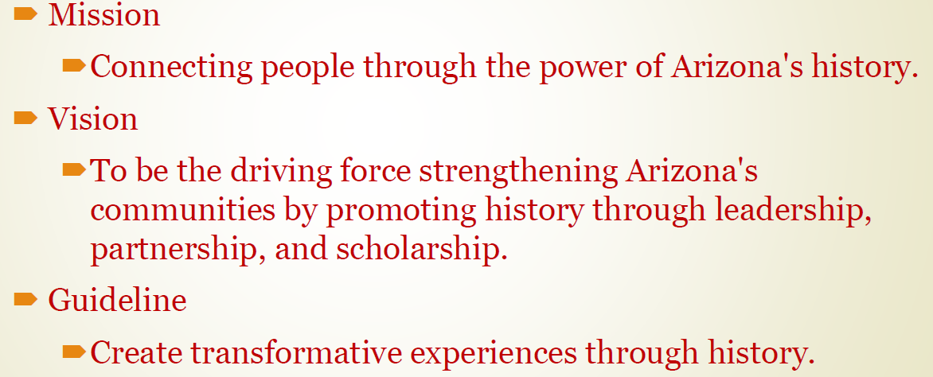

He further described the reorganization of staff. He announced that Les Roe will now be the Vice President in charge of Exhibits for the State. Dr. Burns acknowledged the close relationship between Les and the support organizations in southern Arizona and stated that Les would also be the Southern Arizona Chapter Liaison to maintain that relationship. He further stated that there would be no further relocation of staff and that, per the Bylaws of AHS, the official headquarters for AHS will remain in Tucson.

Election of Members and Officers

President Walter Lane announced that the first three year terms of Bill Cavaliere, Shirley Pinkerton, and Ralph Wong are expiring this year. They are all eligible for second three year terms. Jim Sell moved that we elect Bill Cavaliere, Shirley Pinkerton and Ralph Wong for second three year terms. Jeff Horwitz seconded the motion. A vote was taken and unanimously approved.

President Lane stated that the following people had been nominated as officers by the Nominations Committee: President Ron Green, Vice-President Ralph Wong, Treasurer Shirley Pinkerton and Secretary Linda Head. President Lane asked for any other nominations from the floor. Bill Cavaliere moved that we accept and approve the slate of officers for the coming year. Mark O’Hare seconded the motion. After some further discussion, a vote was taken with unanimous approval.

Announcements

President Lane announced that the next committee meetings will be Wednesday, 2018, and the next regularly scheduled Board meeting will be held on Wednesday, January 2, 2019 @ 3:00.

.
Adjournment

The meeting was adjourned at 4:14.

Respectfully submitted,
Linda S. Head, Secretary

______________________________________
Ron Green, President

